**Hyderabad Transit Hub: User-Centric Transport Scheduling and Complaint Portal on AWS**

**Project Description:**

Hyderabad Public Transport System is a cloud-based web application designed to provide users with easy access to bus and train schedules in the city. The project utilizes Flask for backend development, AWS EC2 for hosting, and Amazon RDS for managing the underlying database. After registering and logging in, users can view transit schedules, including route numbers, starting and ending locations, and timings for buses and trains. The platform also features a complaint submission system for users to file concerns related to specific buses or trains. This cloud-native architecture ensures reliable access to public transport information and a streamlined user experience.

### Scenario 1: Efficient Access to Bus Schedules

In the Hyderabad Public Transport System, AWS EC2 provides a reliable infrastructure to manage multiple users accessing bus schedules simultaneously. For example, a user can log in to the system, navigate to the schedules page, and easily view bus route numbers, starting and ending locations, and timings. Flask handles the backend operations, efficiently serving the schedule data to users in real-time. The cloud-based architecture ensures that the platform can manage multiple users accessing the schedules during peak commuting hours without any delays or downtime.

### Scenario 2: Seamless Complaint Submission for Train Issues

When users encounter issues with train services, they can utilize the complaint submission feature of the Hyderabad Public Transport System. For example, a commuter experiencing repeated train delays logs into the platform and navigates to the complaint submission page from the schedules section. Flask manages the backend processing, ensuring that the user can select the train option, submit the complaint, and receive a confirmation seamlessly. The AWS RDS database stores all complaint data securely, ensuring that issues are tracked and resolved efficiently.

### Scenario 3: Comprehensive Transit Information at User’s Fingertips

Hyderabad Public Transport System provides users with easy access to both bus and train schedules on a single platform. For instance, a commuter logs into the system and navigates to the schedules page. From there, they can switch between viewing bus and

train schedules without any disruptions. Flask ensures that the schedules are fetched quickly from the AWS RDS database, while the cloud-based EC2 hosting guarantees that the platform can handle multiple queries for both buses and trains, offering a smooth and uninterrupted user experience.

AWS ARCHITECTURE

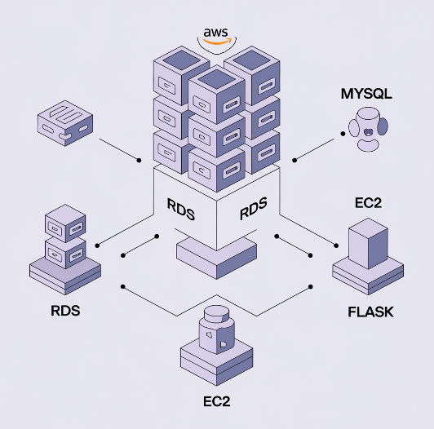

Entity Relationship (ER)Diagram:

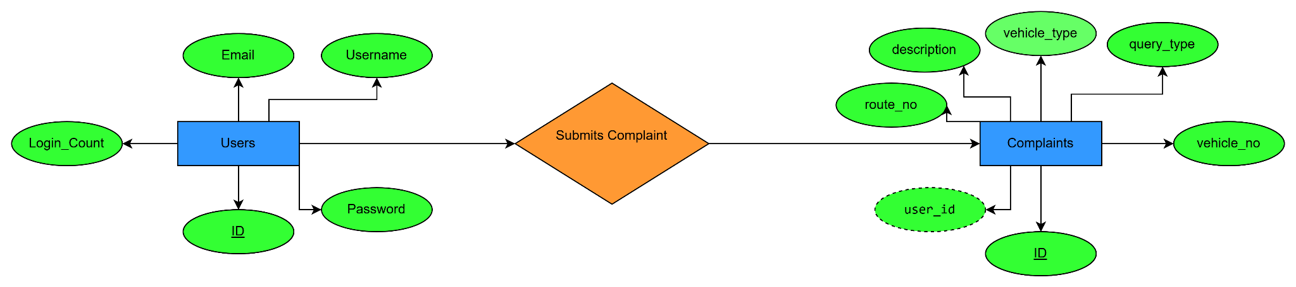

**Pre-requisites:**

### 1. AWS Account Setup: [https://youtu.be/CjKhQoYeR4Q?si=ui8Bvk_M4FfVM-D](https://youtu.be/CjKhQoYeR4Q?si=ui8Bvk_M4FfVM-Dh)h

### 2. Understanding of IAM: <https://youtu.be/gsgdAyGhV0o?si=3qg-bULgkD4LXNvR>

### 3. Knowledge of Amazon EC2 :<https://youtu.be/8TlukLu11Yo?si=MUj0nEAOESRhHUIz>

### 4.MySQL: <https://www.youtube.com/results?search_query=mysql+tutorial>

### 5. RDS connects MySQL:<https://www.youtube.com/results?search_query=mysql+connector+for+rds>

### 6. RDS : <https://www.youtube.com/live/MPau9c7PT74?si=A8OK-zFGbSKkAFWN>

**Project WorkFlow:**

### Project Flow

1. **AWS Account Setup and Login**
   * Set up an AWS account if not already done.
   * Log in to the AWS Management Console to manage resources.
2. **RDS Database Creation and Setup**
   * **Activity 2.1**: Create an RDS Instance.
   * **Activity 2.3**: Install MySQL Workbench.
3. **Frontend Development and Application Setup**
   * **Activity 3.1**: Build the Frontend.
4. **EC2 Instance Setup**
   * **Activity 4.1**: Launch EC2 Instance.
5. **Deployment on EC2**
   * **Activity 5.1**: Deploy to EC2.
6. **Testing and Deployment**
   * **Activity 6.1**: Functional Testing.
   * **Activity 6.2**: Deployment.

**Milestone 1: AWS Account Setup and Login**

* **Activity 1.1: Create AWS Account**
  + Sign up for an AWS account and configure billing settings.

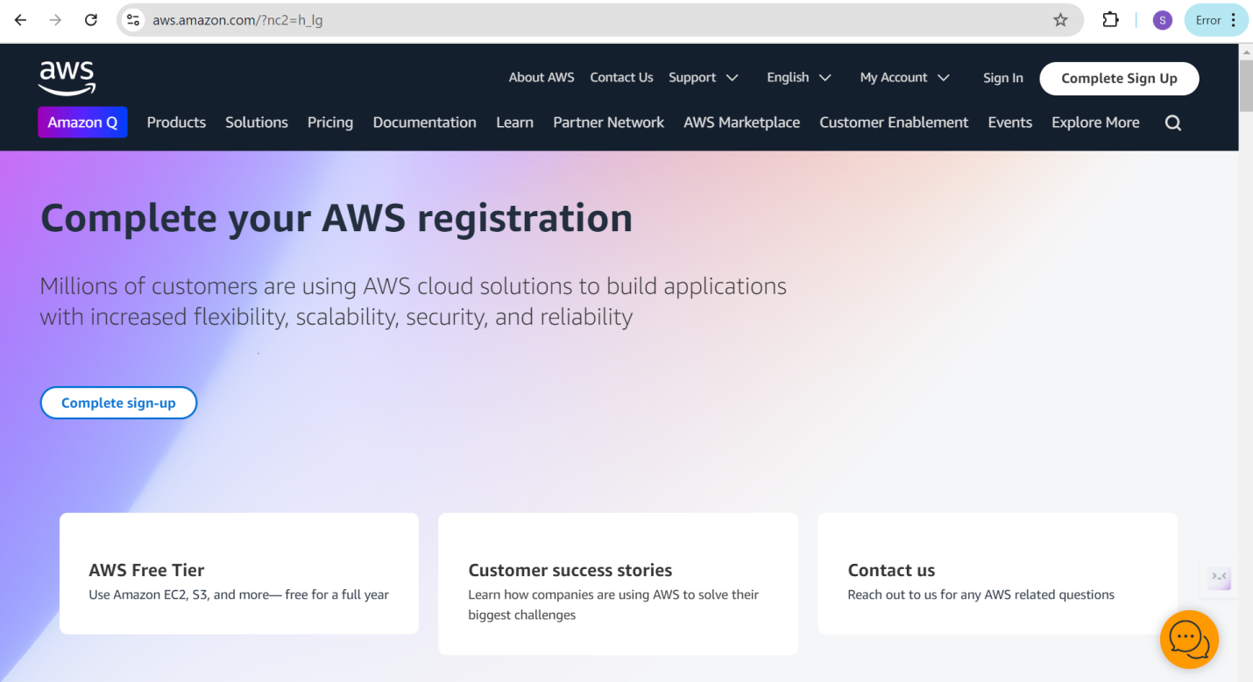

* **Activity 1.2: Login to AWS Management Console**
  + Access the AWS Management Console using your login credentials.

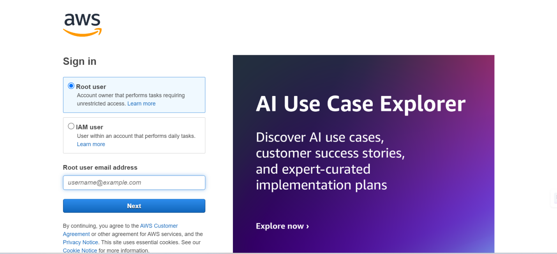

**Milestone 2: RDS Database Creation and Setup**

* **Activity 2.1: Create an RDS Instance**
  + Choose the RDS service from the AWS Management Console.

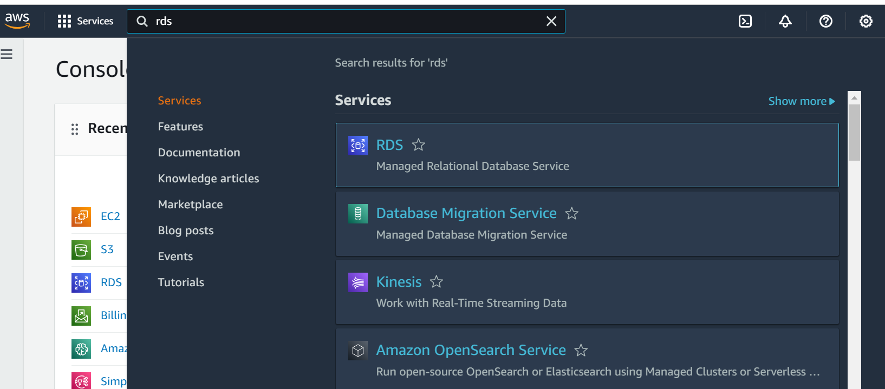

* Click on Create database either on Dashboard or Databases Console

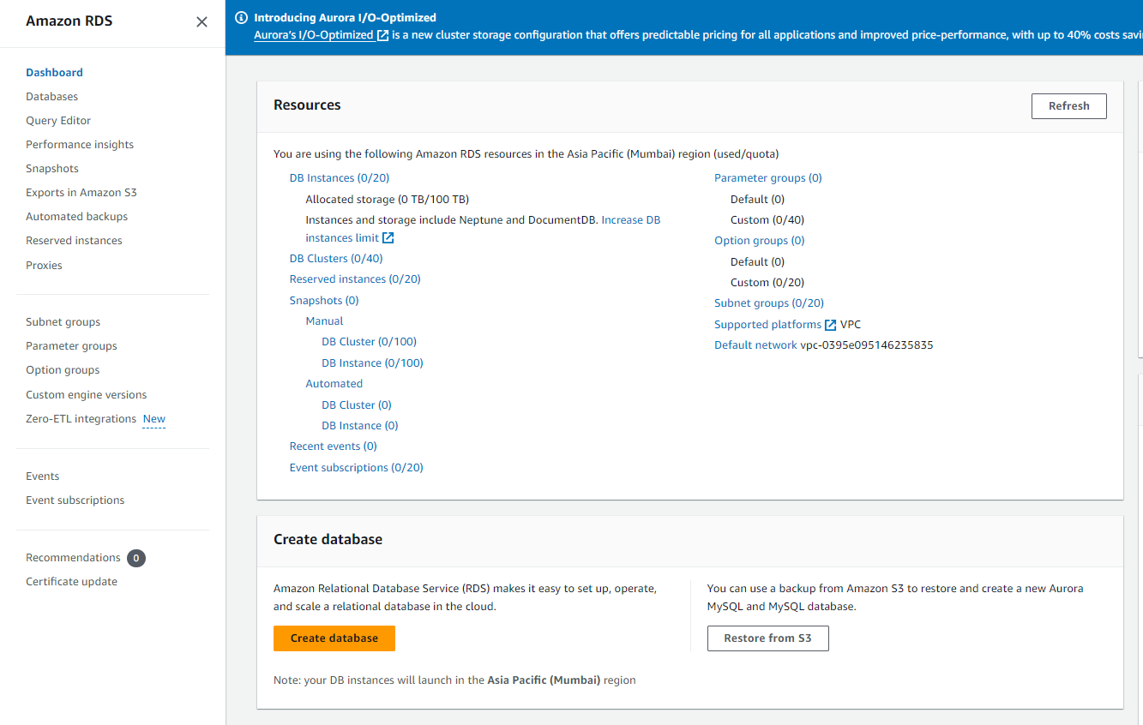

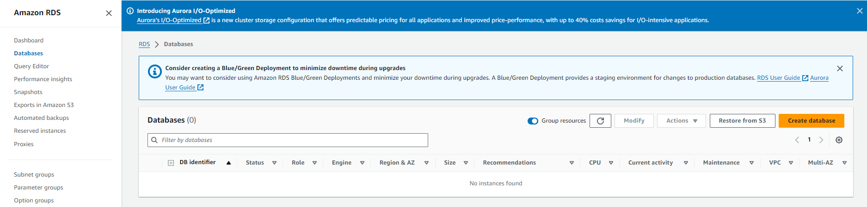

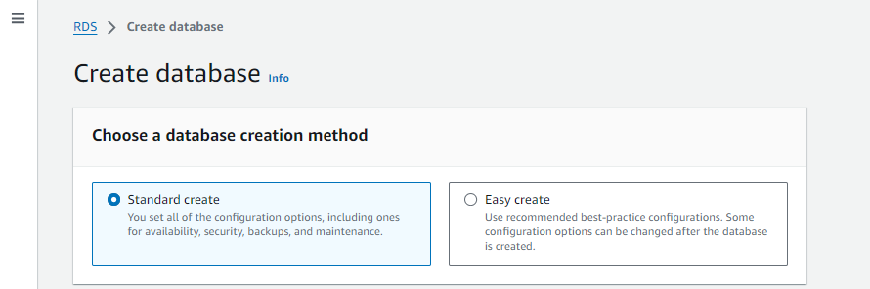

* + Select MySQL as the database engine, configure the instance settings (e.g., storage, instance class), and launch the RDS instance.

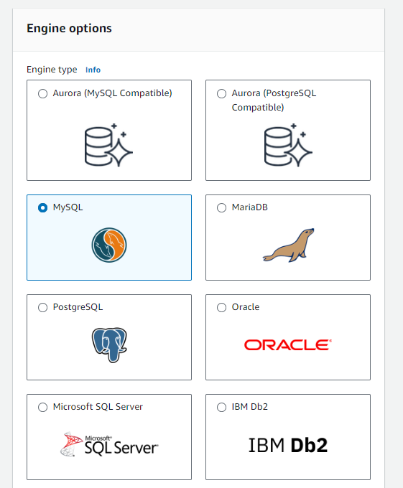

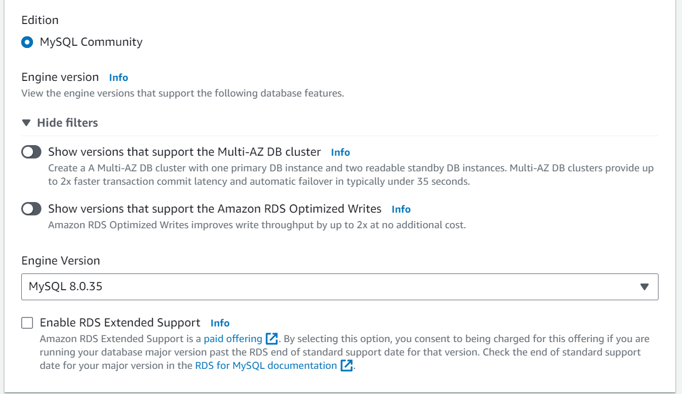

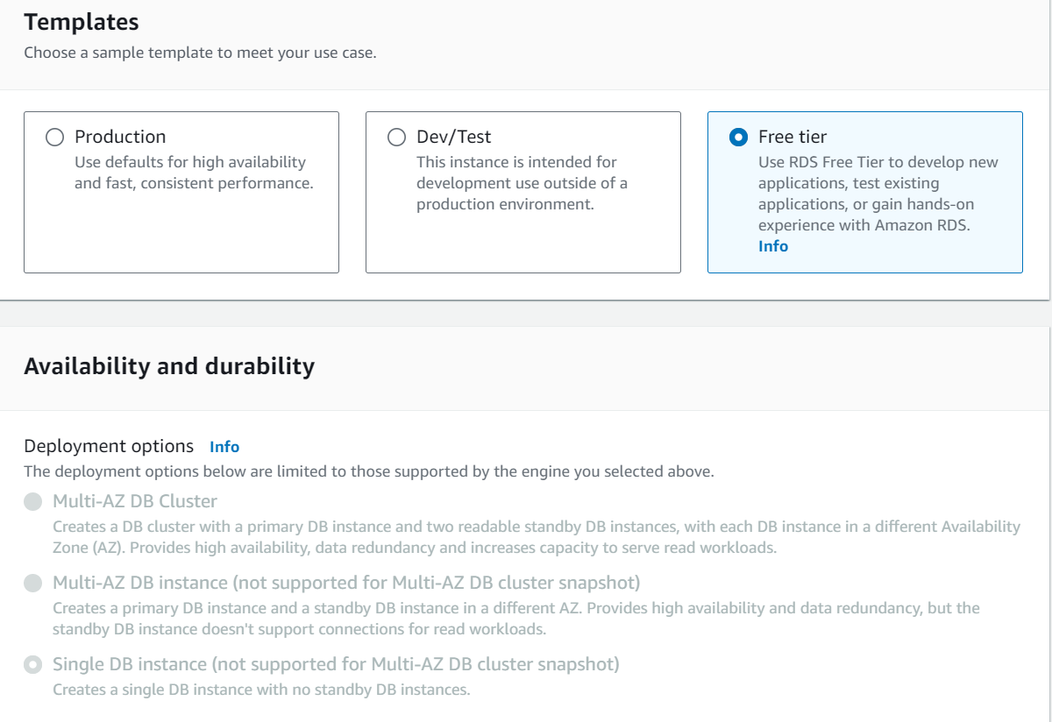

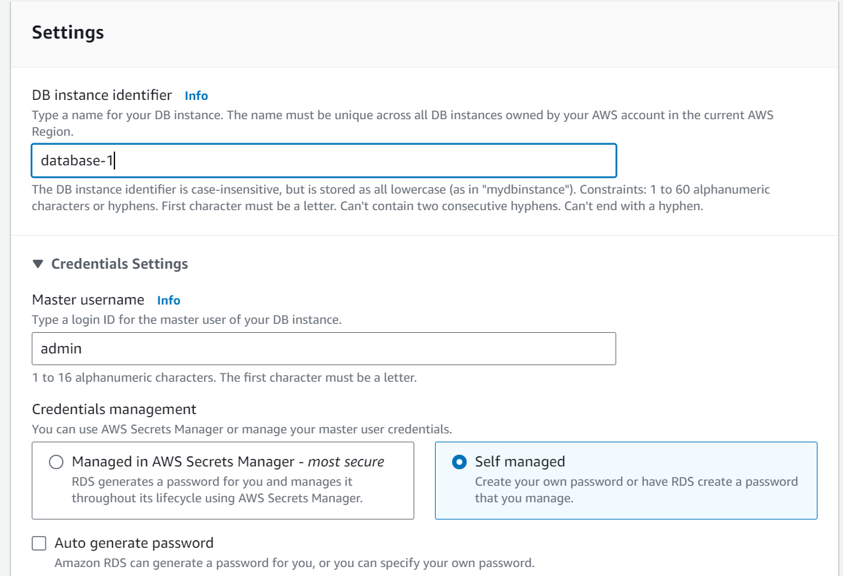

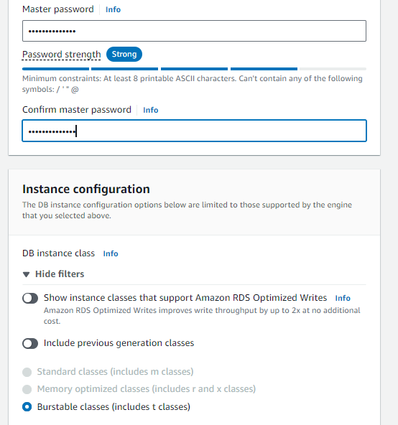

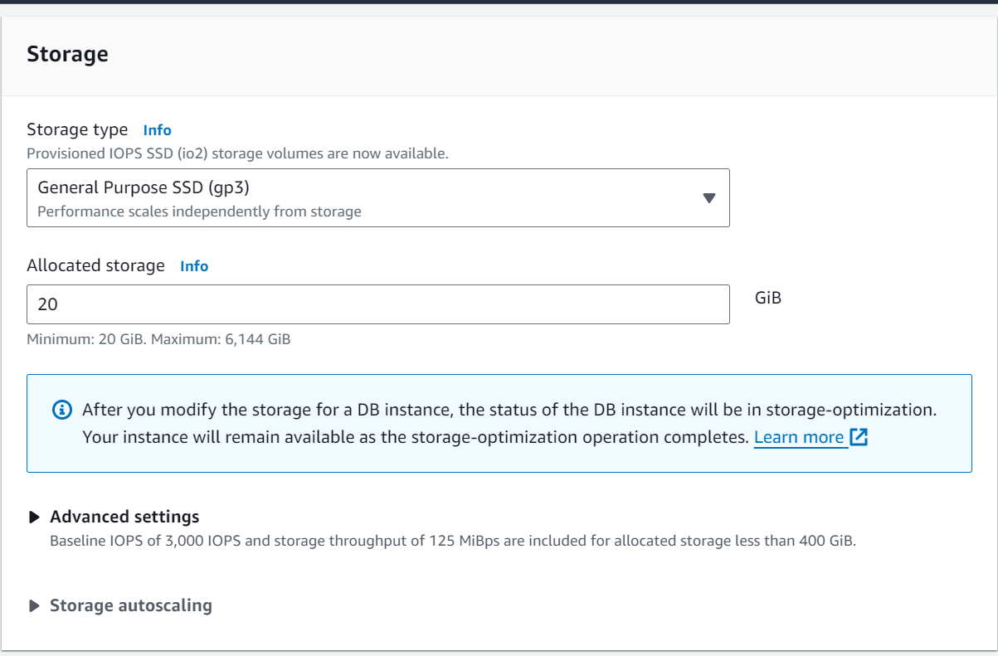

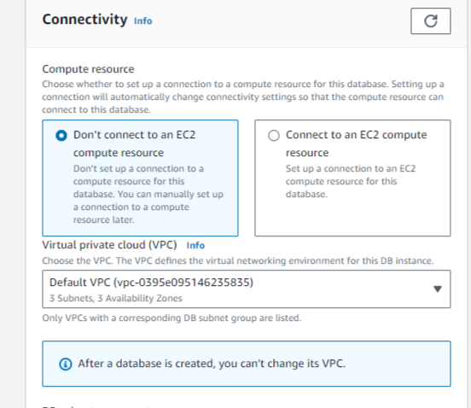

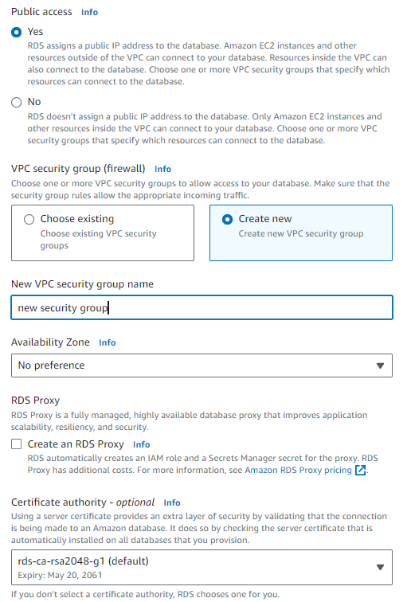

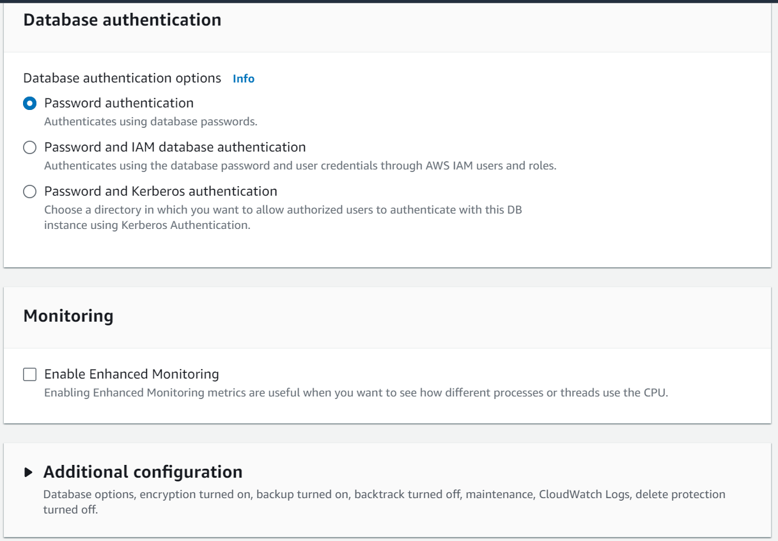

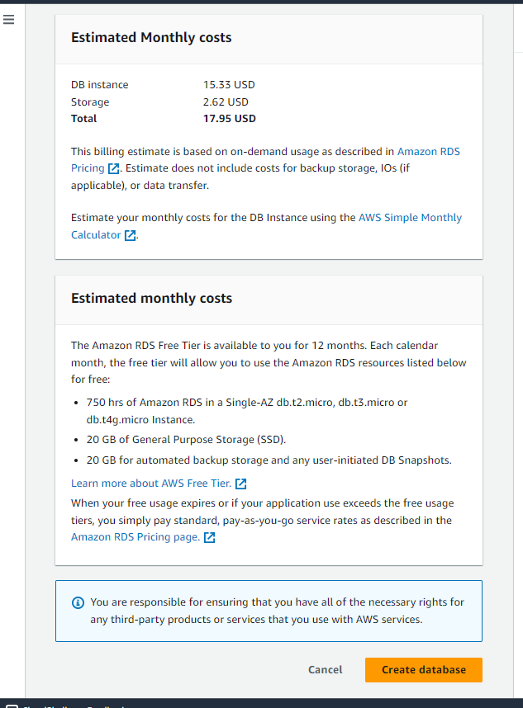

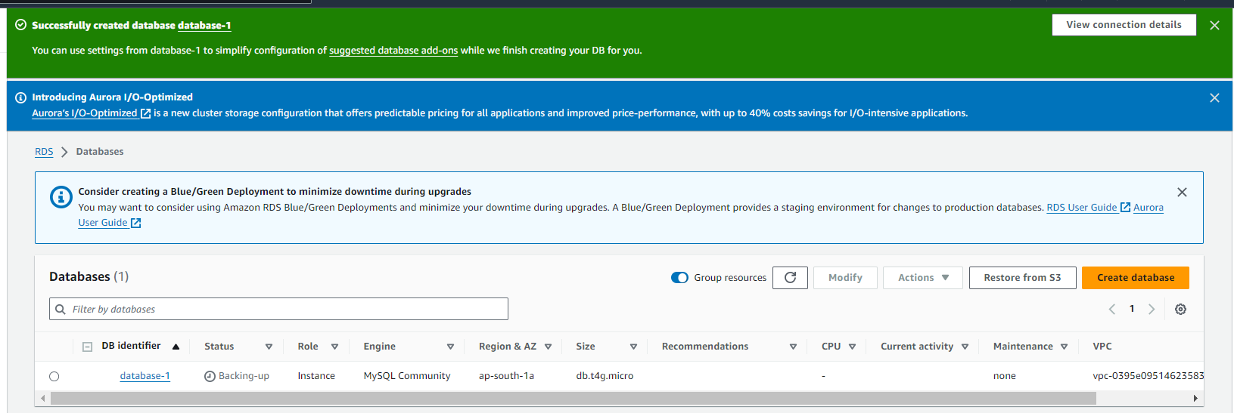

* **Activity 2.2: Configure Database Access**

Set up security groups, create database credentials, and configure access policies to ensure secure connectivity to the database.

* Copy Endpoint Link

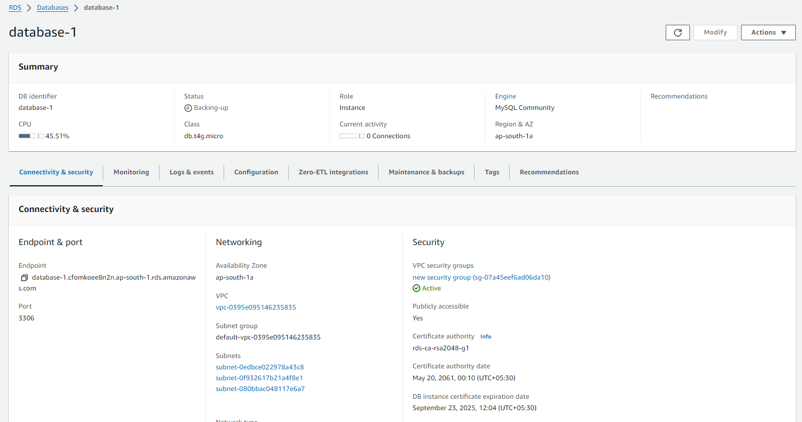

* **Activity 2.3: Install MySQL Workbench**
  + Download and install MySQL Workbench on your local machine for database management.

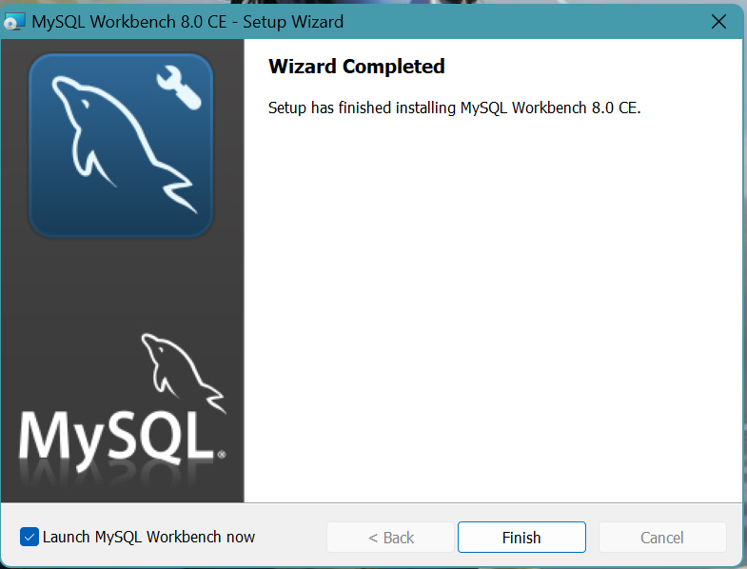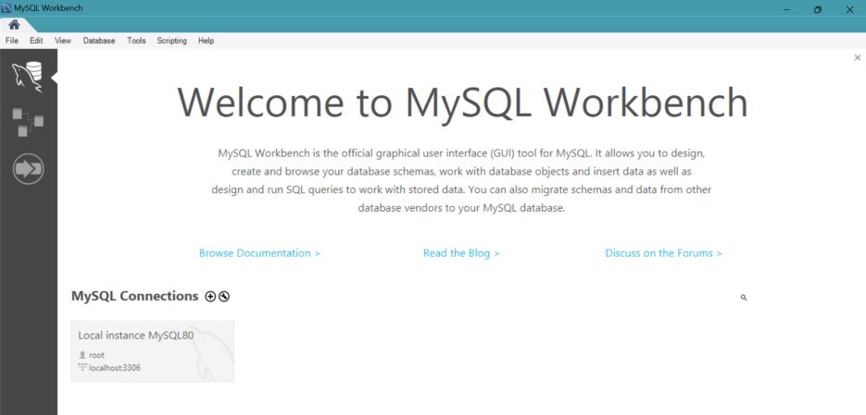

* + Connect to the RDS instance via MySQL Workbench using the endpoint and credentials from AWS

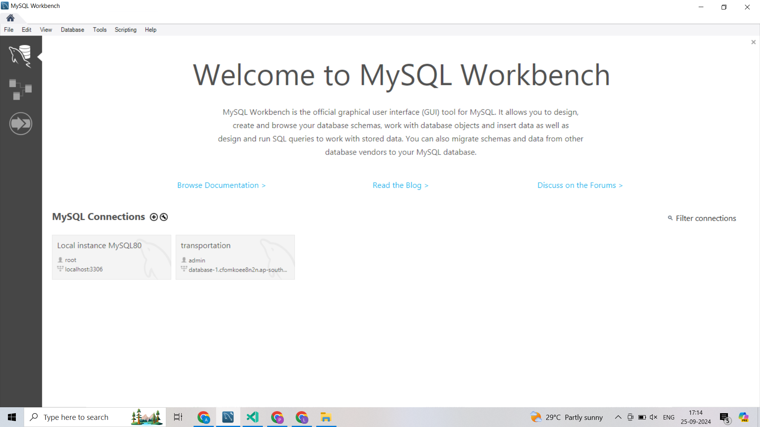

* Give a connection name.
* Copy the endpoint from the RDS database that is created in AWS and paste it in **Hostname.**
* Write the username and enter the password , then click on **Test Connection**.
* Once the connection is successful, you’ll be welcomed with this interface

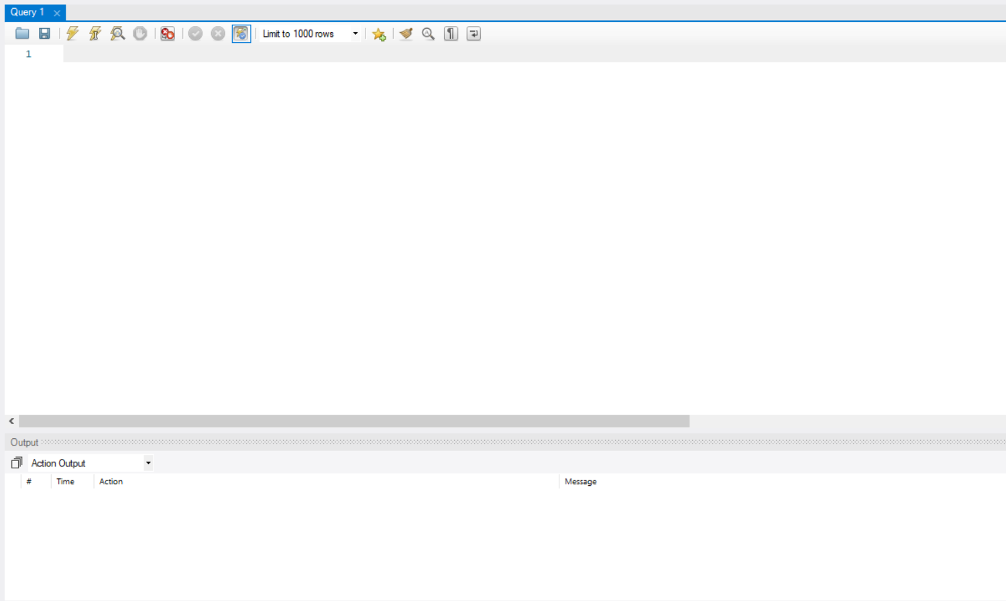

**Activity 2.4: Create the Database and the tables which are required.**

* Create a basic database schema for a public transport schedule and complaint management system.

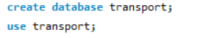

**Tables Created :**

1. **Users:**

* **id** (Primary Key): An integer that auto-increments to uniquely identify each user.
* **email**: A field that stores the user's email address (cannot be null).
* **username**: A field that stores the user's chosen username (cannot be null).
* **password**: A field that stores the user's password (cannot be null, usually hashed).
* **login_count**: An integer field that tracks how many times the user has logged in, with a default value of 0.

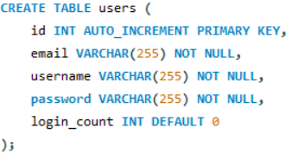

1. **complaints:**

* **id** (Primary Key): A unique identifier for each complaint, auto-incremented.
* **vehicle_type**: A field to store the type of vehicle (e.g., bus or train).
* **route_no**: A field to store the route number of the bus or train.
* **vehicle_no**: A field to store the specific vehicle number (if applicable).
* **query_type**: A field to store the type of complaint (e.g., delay, cleanliness, behavior).
* **description**: A TEXT field to store a detailed description of the user's complaint

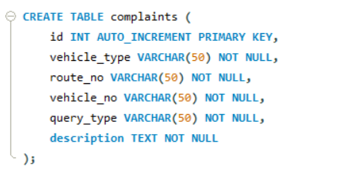

1. **train_schedules:**

* **id** (Primary Key): A unique identifier for each train schedule, auto-incremented.
* **section_no**: An integer field to store the section number associated with the train route.
* **train_route_no**: A field to store the specific train route number.
* **starting_station**: A field to store the starting station name.
* **ending_station**: A field to store the ending station name.
* **in_between_stations**: A TEXT field to list the names of the stations between the starting and ending stations.
* **departure_time**: A TIME field to store the scheduled departure time from the starting station.
* **arrival_time**: A TIME field to store the scheduled arrival time at the ending station

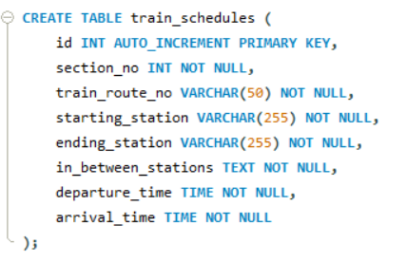

**4.bus_schedules:**

* **id** (Primary Key): A unique identifier for each bus schedule, auto-incremented.
* **section_no**: An integer field to store the section number associated with the bus route.
* **bus_route_no**: A field to store the specific bus route number.
* **starting_point**: A field to store the name of the starting point of the bus route.
* **ending_point**: A field to store the name of the ending point of the bus route.
* **departure_time**: A TIME field to store the scheduled departure time from the starting point.
* **arrival_time**: A TIME field to store the scheduled arrival time at the ending point.

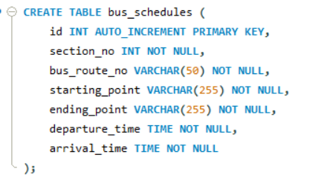

### Data Operations:

1. Data Insertion into users, complaints, bus_schedules, train_schedules:  
   We inserted multiple rows into the users, complaints, bus_schedules, and train_schedules tables to populate the database with relevant information for user accounts, filed complaints, and transport schedules.

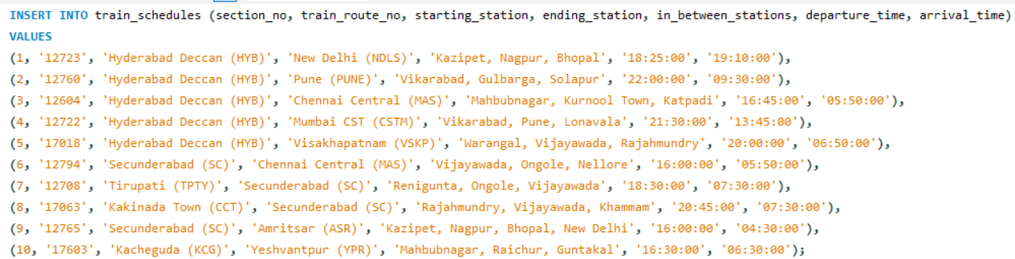

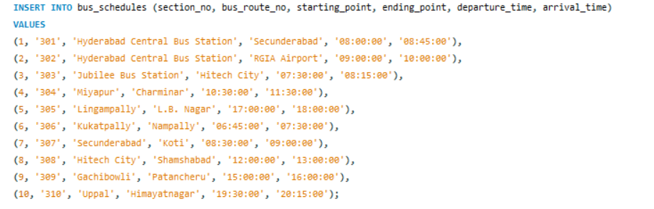

2.Data Retrieval:

We retrieved data from each table to view the stored information, including user details, filed complaints, bus schedules, and train schedules. This allowed us to verify that the data was correctly inserted and accessible for displaying transport schedules and managing user complaints in the application.

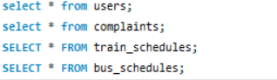

**Milestone 3: Frontend Development and Application Setup**

* **Activity 3.1: Build the Frontend**

We developed the necessary HTML, CSS, and Python files using Flask to create a user-friendly frontend interface for the Hyderabad Public Transport System. This interface allows users to register, log in, check bus and train schedules, and file complaints seamlessly. The application also provides responsive design and a smooth user experience across devices.

* + Develop HTML, CSS, and Python-based Flask application files for the Hyderabad Public Transport System's frontend interface.

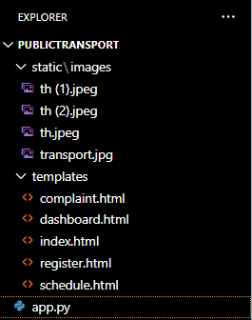

**Description of the code :**

* **Flask App Initialization**: Initializes a Flask application with a secret key for sessions.

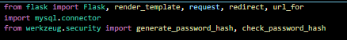

* **Database Configuration**: Connect app.py (Flask application) to the MySQL RDS database by configuring database connection settings and verifying connectivity.

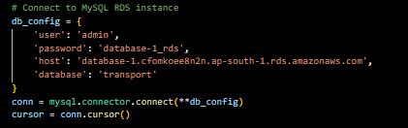

* **Routes:** Renders the login and registration pages for user authentication and account creation.

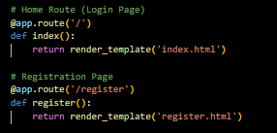

* **Register User:** Collecting registration data, hashes the password, and stores user details in the database.

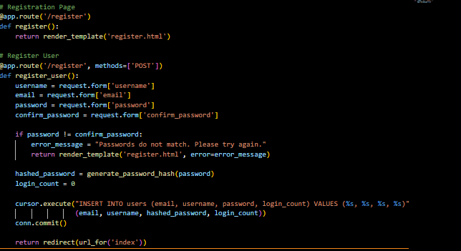

* **login Route (GET/POST)**: Verifies user credentials, increments login count, and redirects to the dashboard on success.

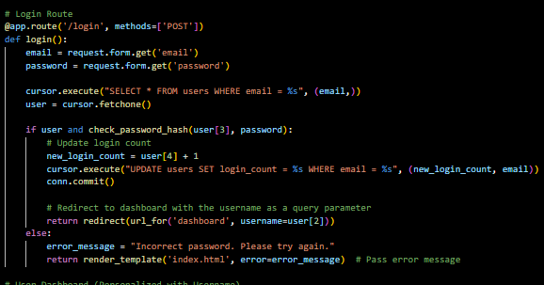

* **Web pages:** Displaying the user’s personalized dashboard and allows access to the schedule page for viewing bus and train schedules.

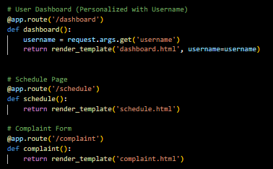

* **Complaint Form:** Handles complaint submission by gathering form data, validating inputs, and preparing it for storage.
* 

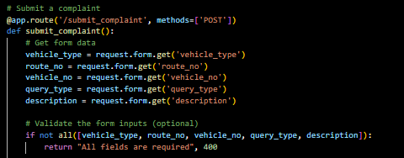

* **MySQL database:** Inserts the validated complaint details into the database for tracking and resolution.

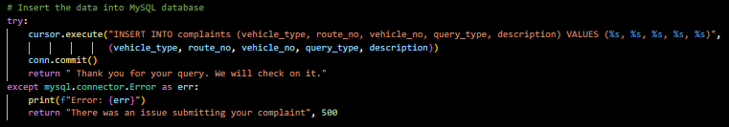

**Initiating Flask app:**

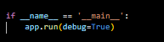

**Milestone 4: EC2 Instance Setup**

* Note: Load your Flask app and Html files into GitHub repository.

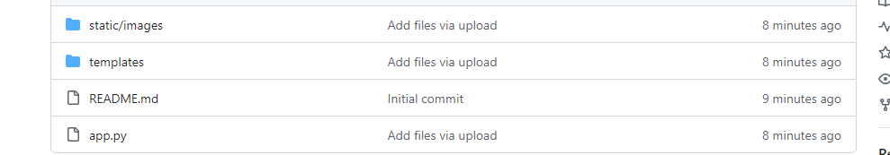

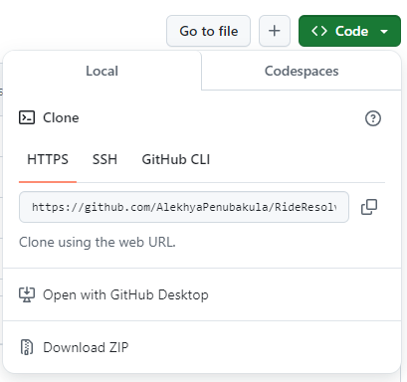

* **Activity 4.1: Launch EC2 Instance**
  + Choose a Linux-based EC2 instance from the AWS Console to host the **Hyderabad Public Transport System** application.

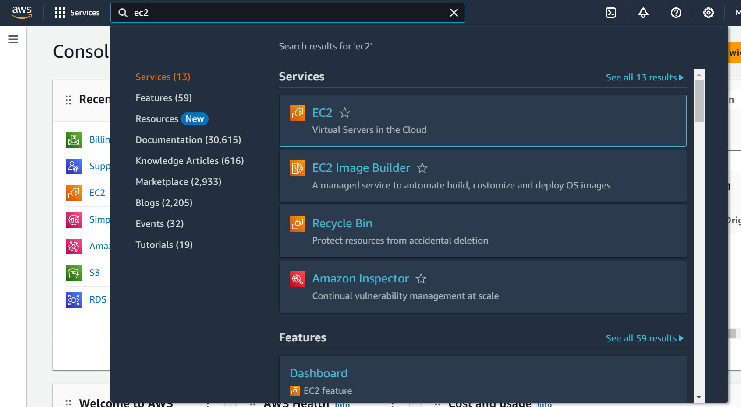

* Click on Launch instance to launch EC2 instance

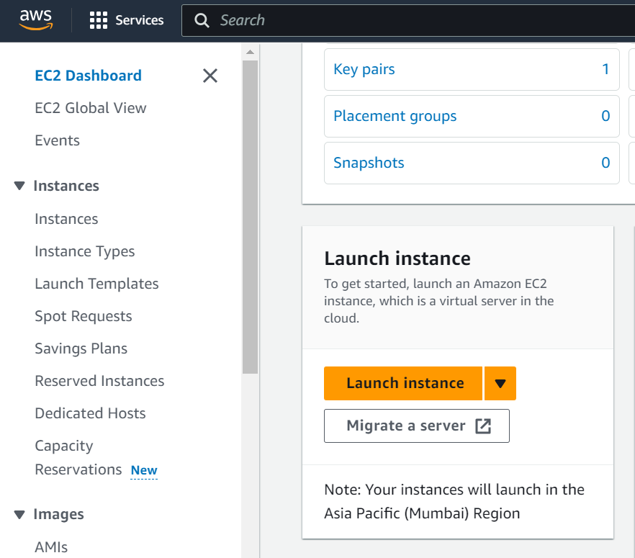

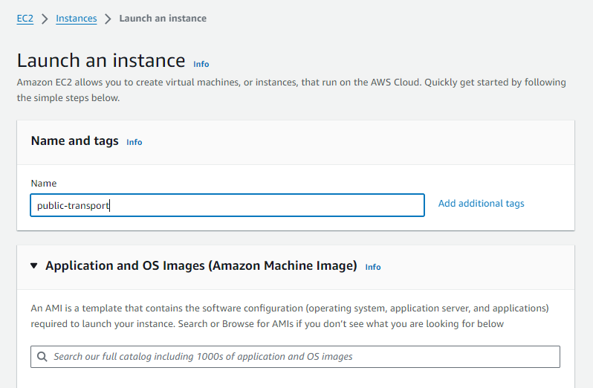

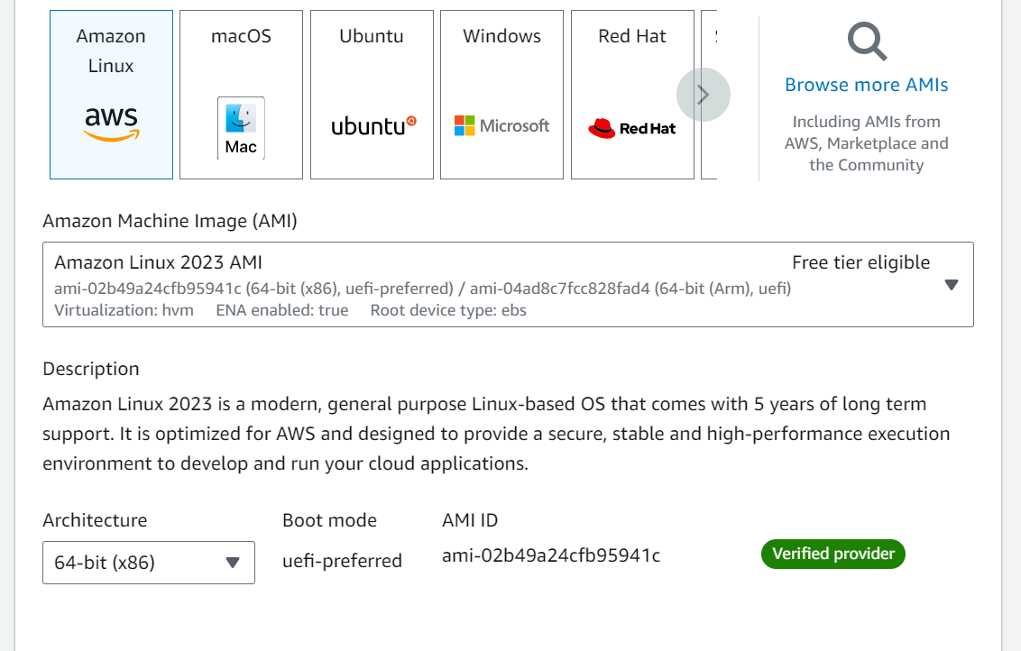

* Create a new key pair

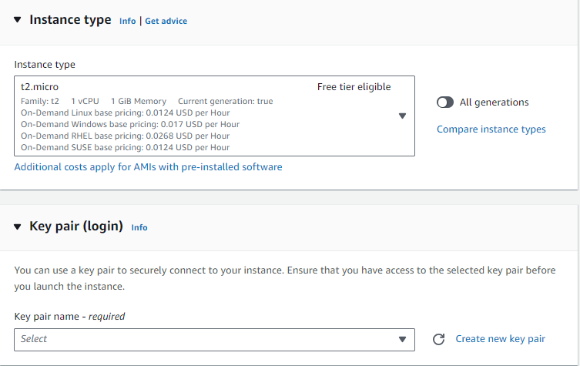

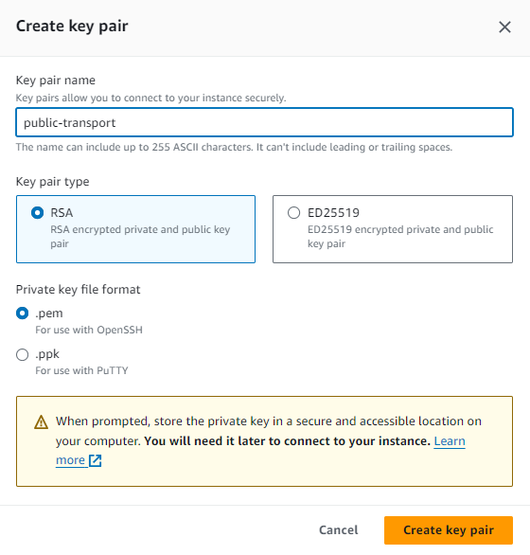

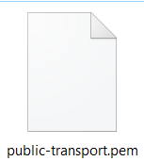

* **Activity 4.2: Configure Network Settings**
  + Set up the security group to allow HTTP, HTTPS, and SSH traffic.

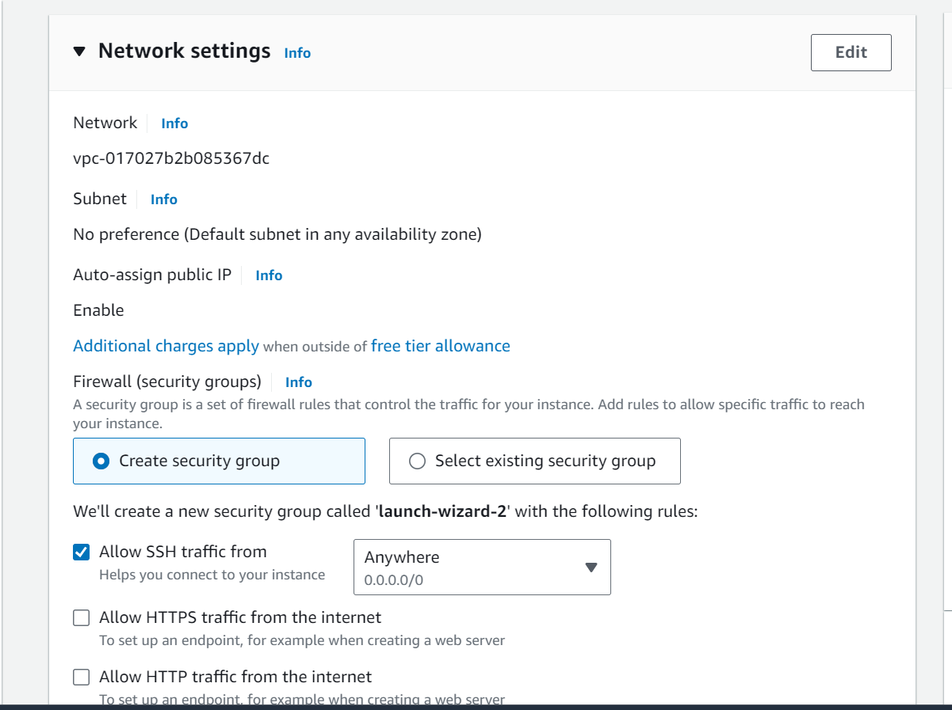

* + Create and download the key pair for SSH access.

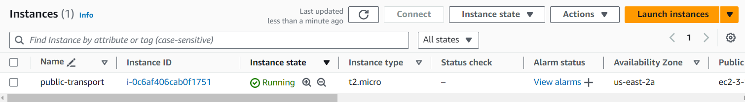

* Setting up Inbound and Outbound rules

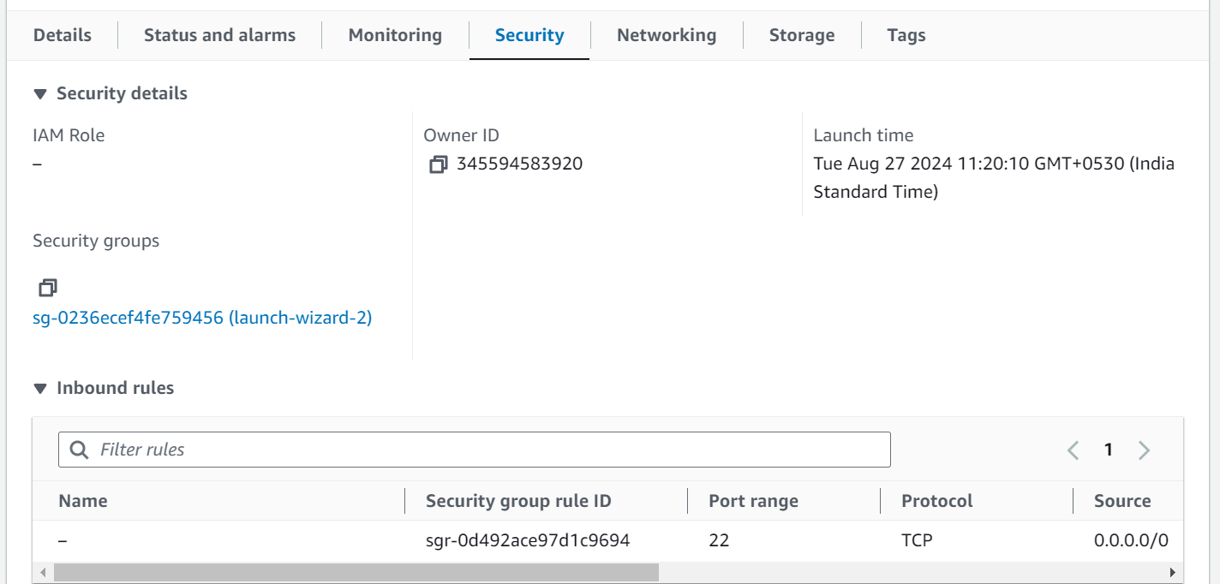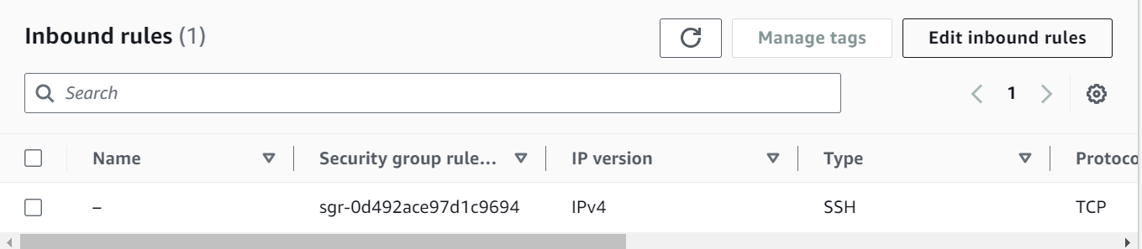

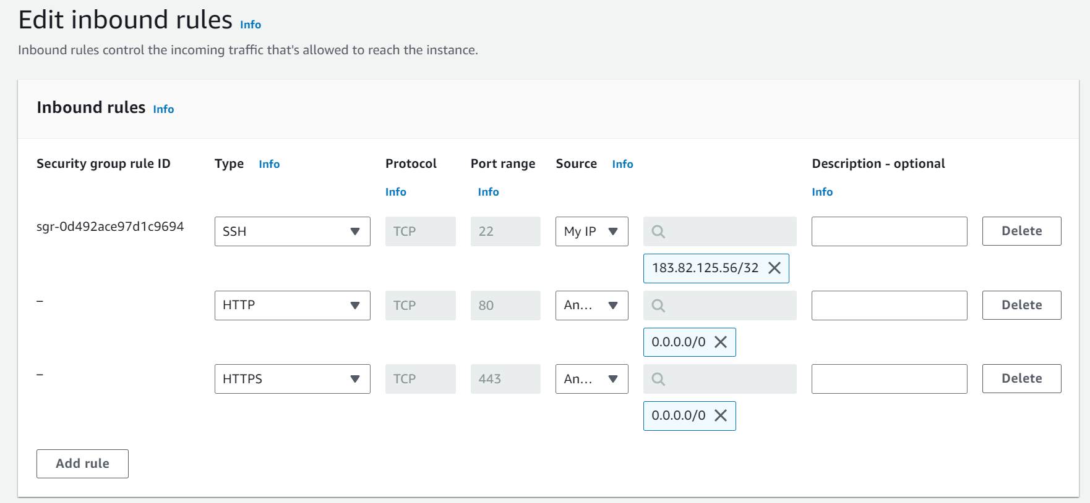

* Add Type : HTTP > Source : Anywhere
* Add Type : HTTPS > Source : Anywhere

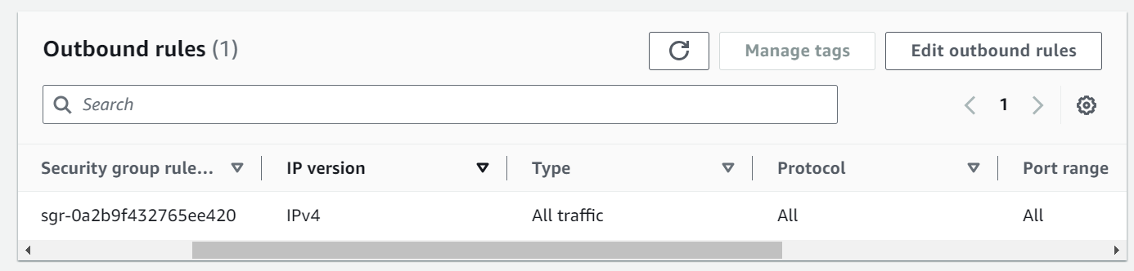

**Milestone 5: Testing and Deployment**

**Activity 5.1: Deploy to EC2**

1. Connect EC2 terminal.
2. Set up any necessary environment variables, including database connection strings.
3. Configure the web server to serve your application.
4. Start your application and ensure it's accessible via the EC2 instance's public IP or domain.

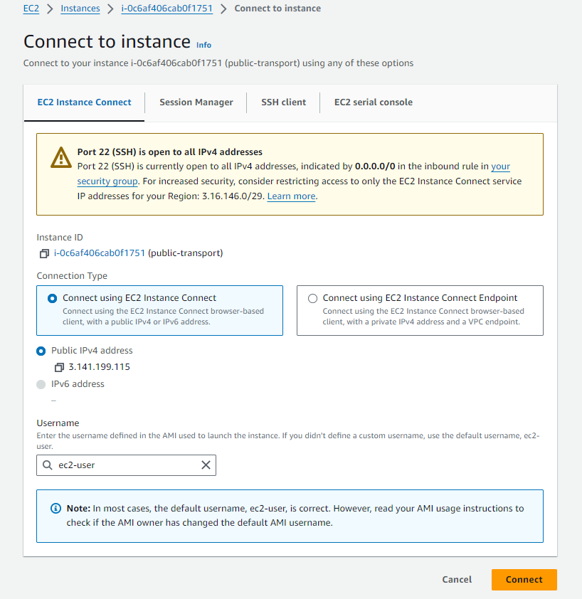

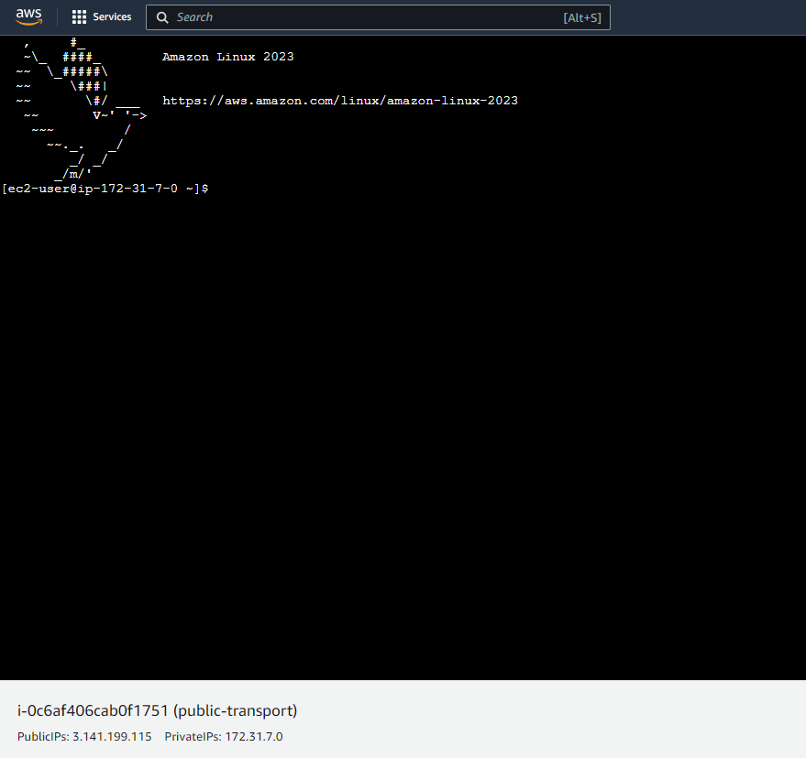

1. Run the below commands on ec2 terminal
2. sudo yum update -y
3. sudo yum install python3 -y
4. sudo pip3 install virtualenv
5. python3 -m venv venv
6. source venv/bin/activate
7. pip install flask
8. git clone <https://github.com/AlekhyaPenubakula/RideResolve.git>
9. cd your-flask-app
10. python app.py
    * Run the Flask app on the EC2 instance

**Milestone 6: Testing and Deployment**

* **Activity 6.1: Functional Testing**
  + Test the **Hyderabad Public Transport System** application for functionality, including database interactions and frontend features.
  + Run the Flask app using the command: python app.py
  + It will provide you with a link to access the application in your browser for further testing.

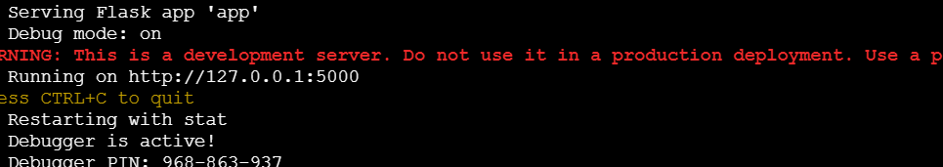

**Access the website through:  
 PublicIPs:** [**https://3.141.199.115:5000**](https://43.204.214.27:5000)

* **Activity 6.2: Deployment**
  + Deploy the application in a production environment, ensuring high availability and performance.

Click on the link above and it will take you to the website:

**Login Page:**

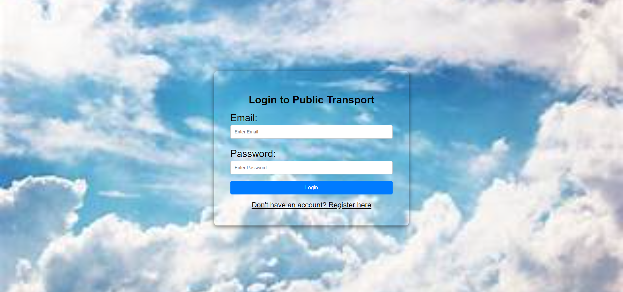

**Register Page:**

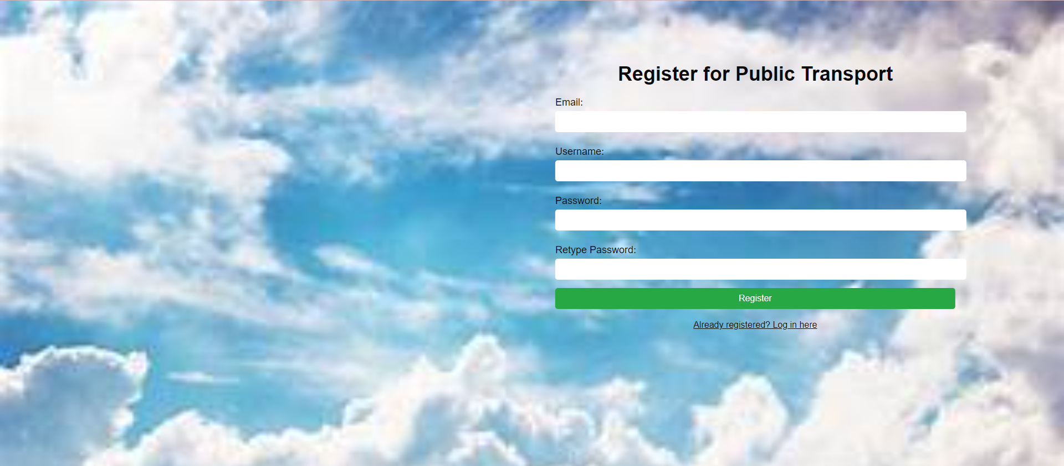

**Home page:**

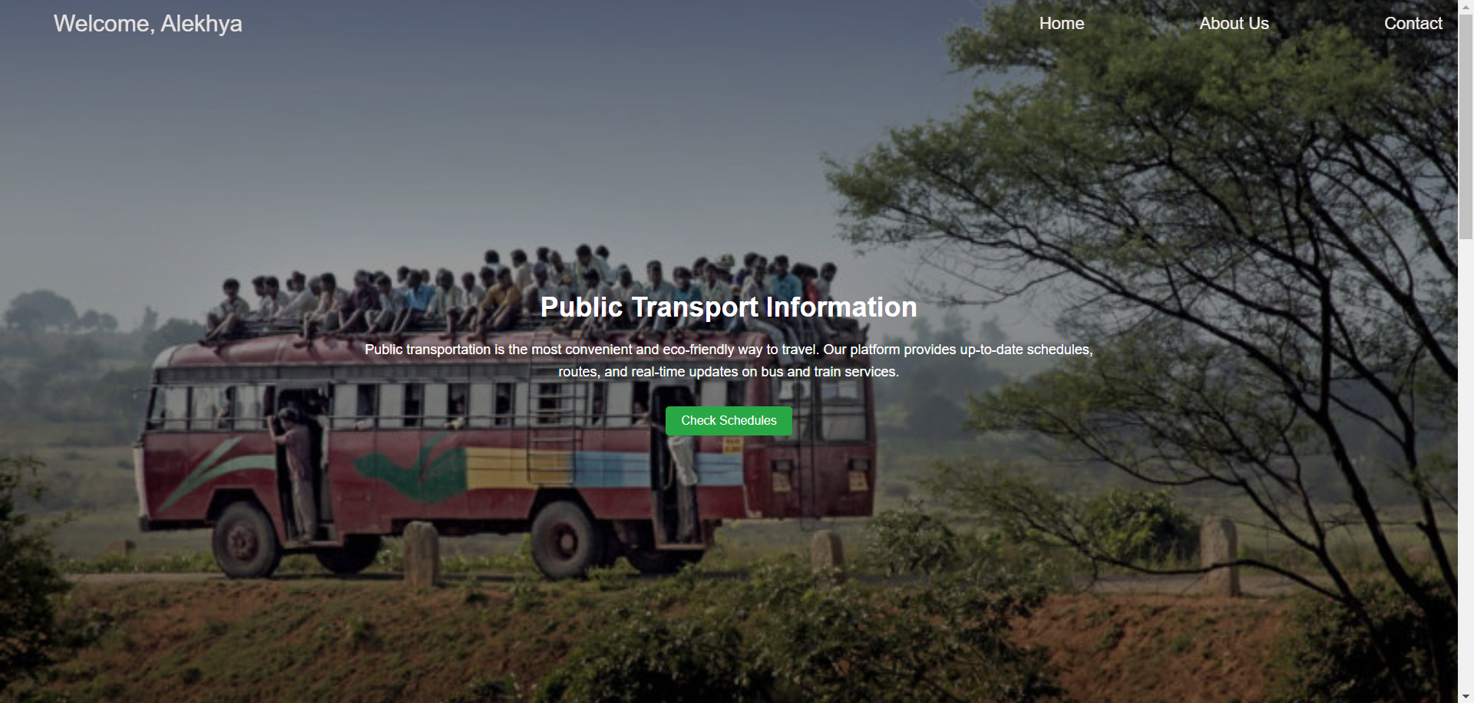

**About Us page:**

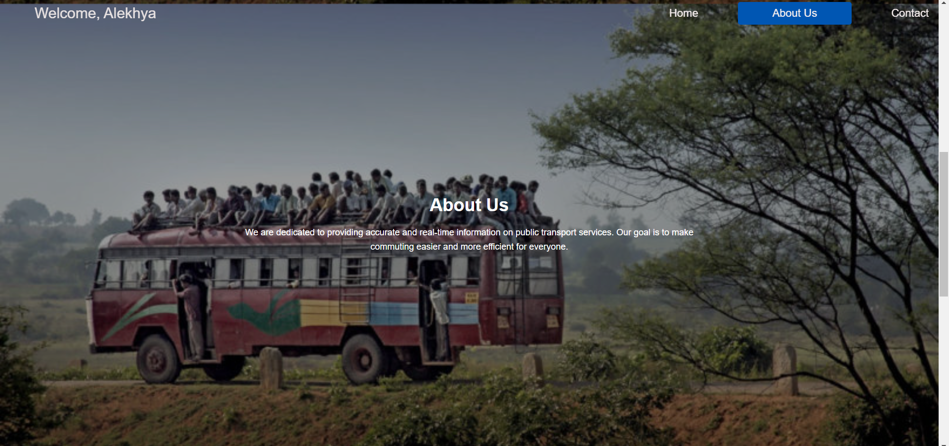

**Contact Page:**

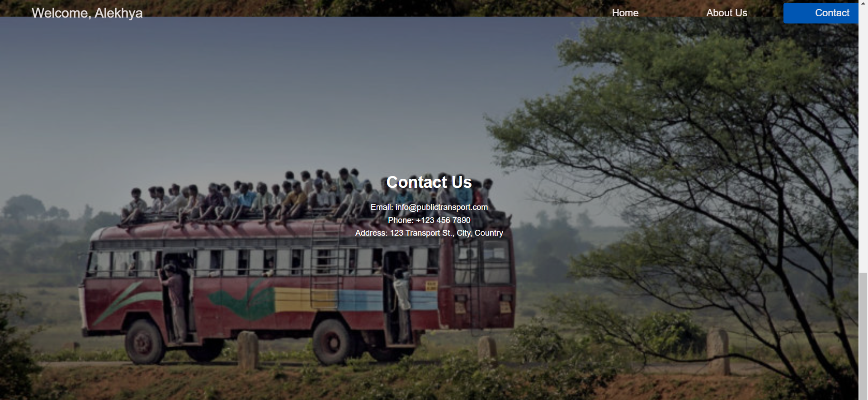

**Schedules page:**

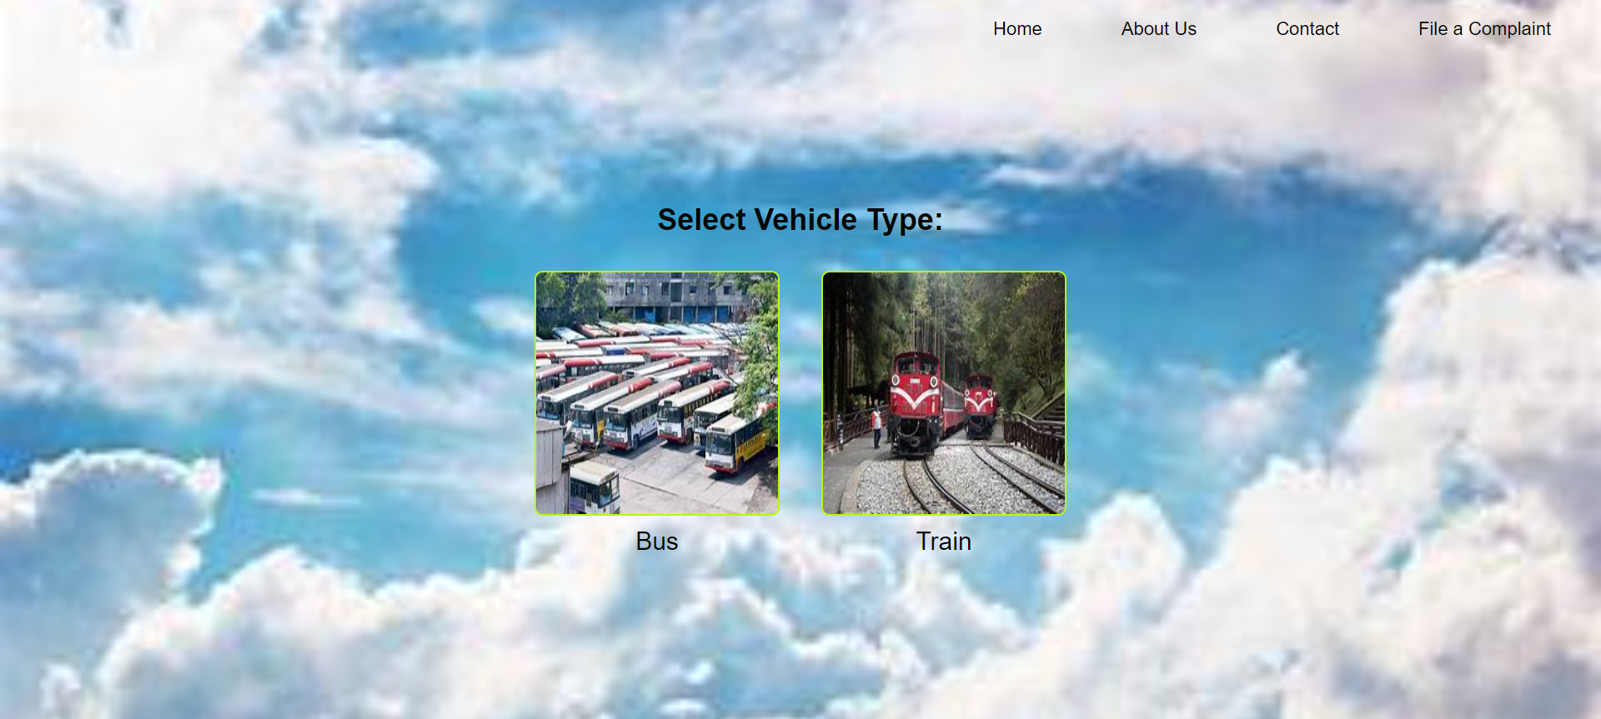

**Bus Schedules Page:**

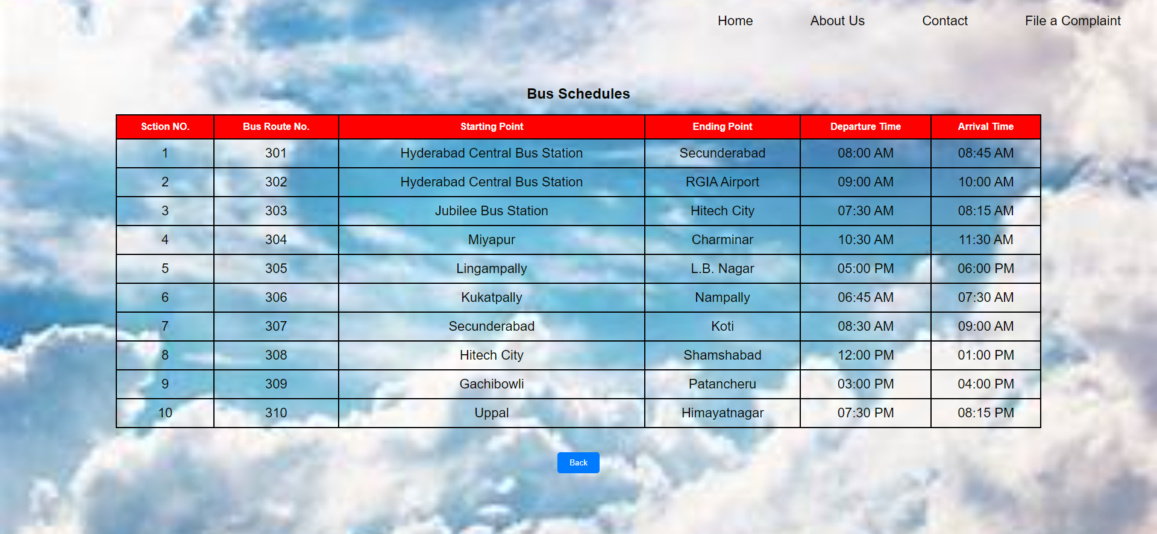

**Train Schedules Page:**

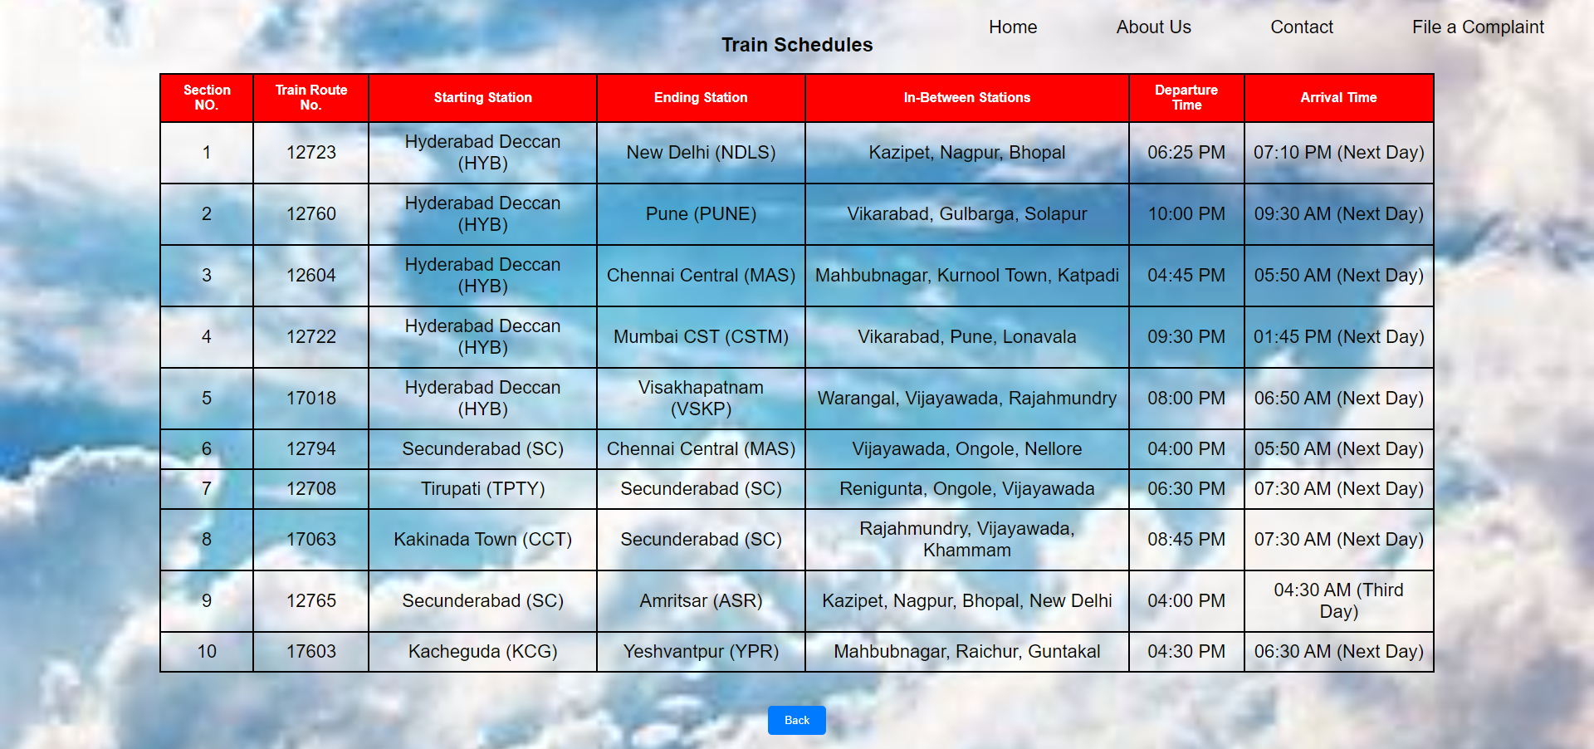

**Complaint Filing Page:**

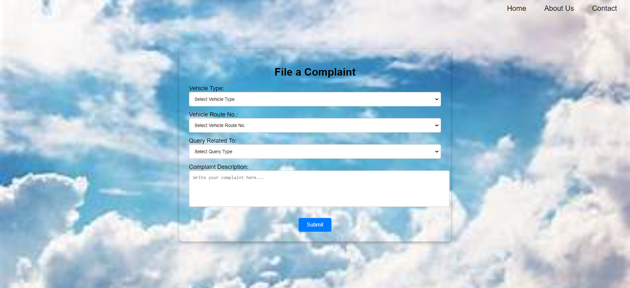

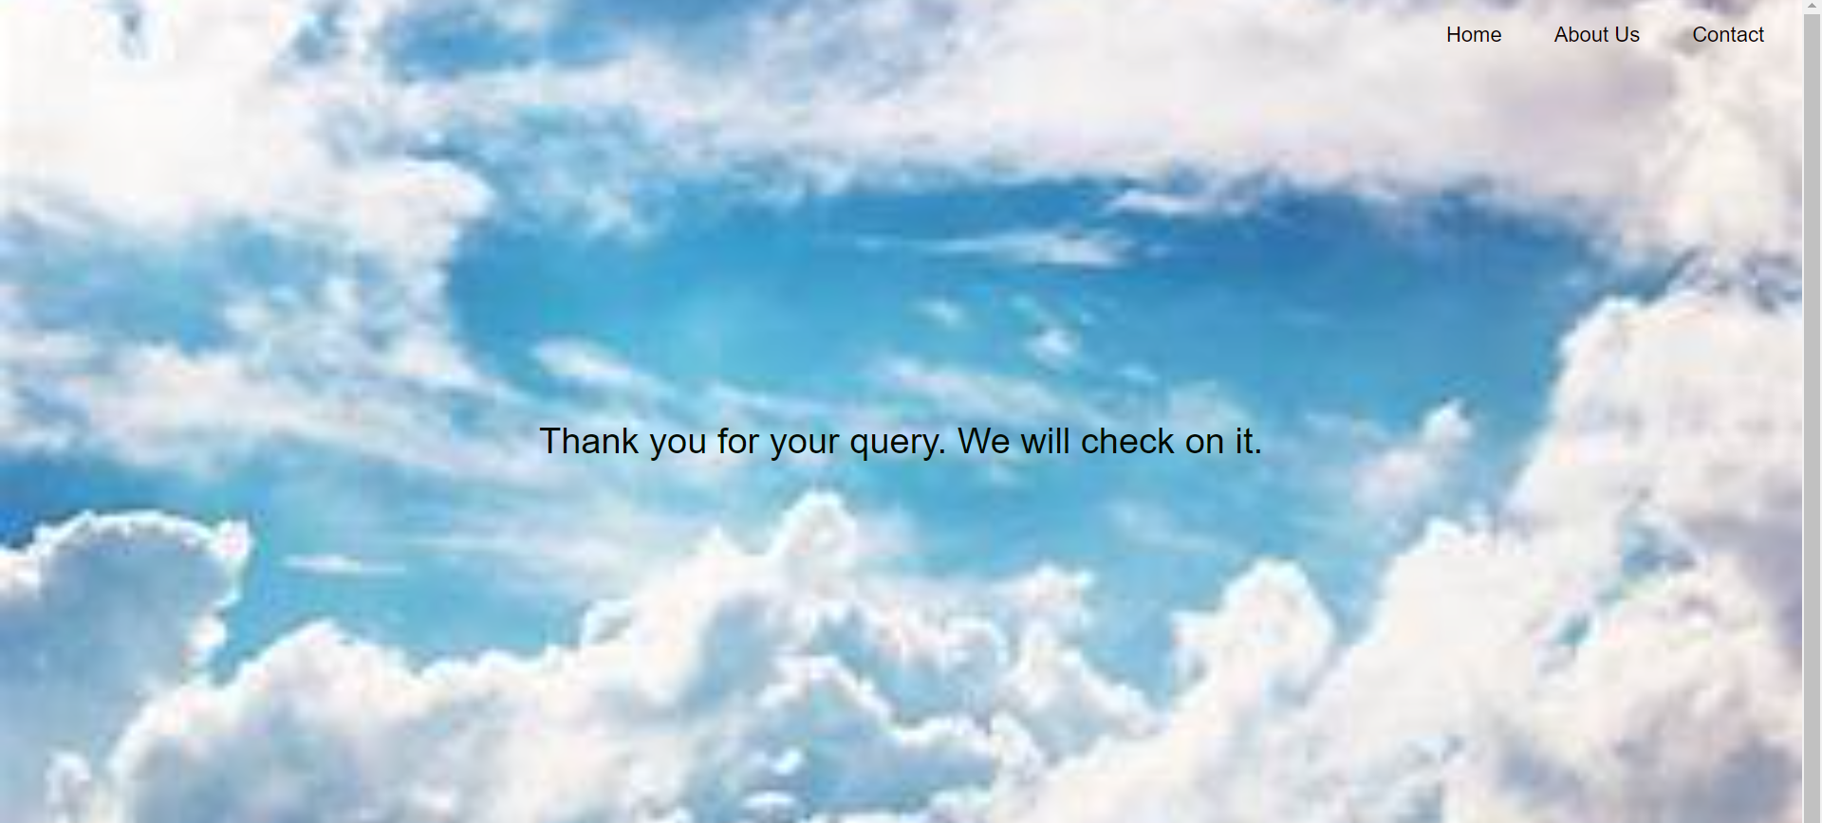

* **Activity 6.3: Check the updations in the mysql database.**

**MySql Database updations :**

1. **Users table :**

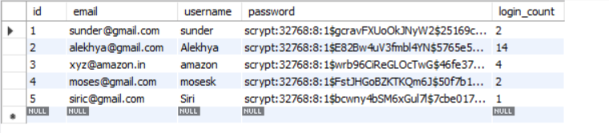

1. **Complaints table :**

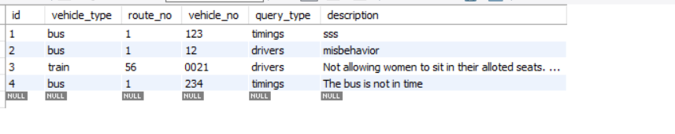

1. **Train Schedules table :**

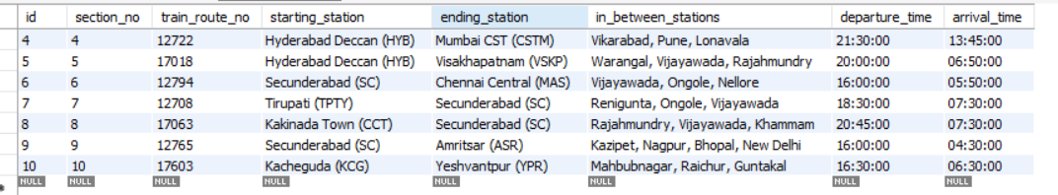

1. **Bus schedules table:**

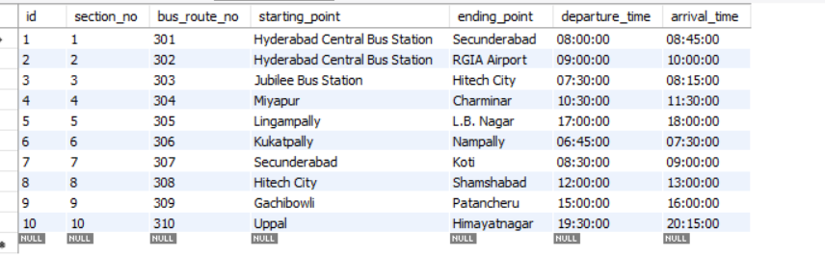

**Milestone 7: Monitoring and Optimization**

* **Activity 7.1: Performance Monitoring**
  + Set up AWS CloudWatch for monitoring EC2 and RDS performance metrics.
  + Implement alerts and notifications for critical performance thresholds.
* **Activity 7.2: Optimization**
  + Optimize the server and database configurations based on monitoring results, including adjusting instance types and query optimization.

**Conclusion:**

The Hyderabad Public Transport System project exemplifies the development of a robust and user-friendly public transport schedule and complaint management platform using AWS. By leveraging Flask alongside MySQL RDS, it ensures efficient data management and secure backend operations. The deployment on AWS EC2 enables flexible scaling and reliable performance, ensuring users can access schedules and file complaints seamlessly. Each phase, from database configuration to frontend development and deployment, was carefully executed to provide an optimal user experience. Additionally, AWS CloudWatch is used to monitor performance and maintain operational efficiency. Overall, the project demonstrates how AWS services can support a dynamic and scalable public transport solution for a city like Hyderabad.